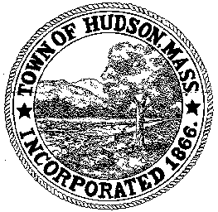

CONSERVATION COMMISSION
78 Main Street, Hudson, MA 01749
(978) 562-2020

Paul Byrne, Chairman W. Minot Wood, Vice Chairman David Esteves, Member

Terrence Joyce, Member Leif Longtine, Member Joseph Rodrigues, Member Al Tashian, Member

May 20, 2010 7:00 P.M.

- Preliminaries
  - Open Meeting
  - Roll Call
1.3 Additions or Deletions to the agenda

2.0 Hearings and Appointments
2.1 DEP 190-546
Applicant: Jacob and Diane Welton
Location: 308 Chestnut Street
Project Description: Raze the existing home and construct a new home 66’feet from the edge of the wetland.
No work inside existing tree line, 4700 SF of disturbance inside 2nd riparian zone, fence . 66’ closest proximity to wetland. Motion to close public hearing and issue an Order of Conditions once revised plan is received.
2.2 RDA 394
Applicant: Frank Puma
Location: 3 Eaton Drive
Project Description: 14’x12’ shed

2.3 RDA 395
Applicant: Richard Kiley
Location: 75 Hunter Avenue
Project Description: Decommissioning an existing failed cesspool; and excavation and construction of a new septic system.

2.4 DEP 190-532
Applicant: Mark Costa
Location: 256 Washington Street
Request for Certificate of Compliance

2.5 Enforcement Order - continued
Applicant: Charles Freeman
Location: 7 Freeman Circle
Paul made a motion to continue the public hearing to May 27, 2010 at 7:30PM.
All members are in favor.

3.0 General Business
3.1 Old Business

3.2 New Business

4.0 Adjournment

